Getting Started

Let’s have a look at what you need to download and install to start writing a game using PunyInform. For this article, I will be using Windows, but you can also use PunyInform on Mac or Linux.

Step 1: Install the PunyInform library
Go to https://github.com/johanberntsson/PunyInform/releases and download the newest version of PunyInform (the version that comes first on the page) by clicking on “Source code (zip)” under Assets. When it has finished downloading, click on the Zip archive in your browser window to open the archive in Windows Explorer, click on “Extract All” near the top of the window, just below the menu bar. Pick a folder where you want to place the PunyInform files. Windows Explorer will probably suggest something like “C:\Users\MyUsername\Downloads\PunyInform-1_2\” and that should work fine. You can always rename and/or move the folder later.

Step 2: Get the compiler
PunyInform is a library for the Inform 6 programming language. To use it, you will need to download the compiler, called “inform” or “inform6”. PunyInform requires at least version 6.34 of the compiler. If you use Windows, it’s available as a binary executable, so you can just download it and start to use it. Go to http://www.ifarchive.org/indexes/if-archiveXinfocomXcompilersXinform6Xexecutables.html and download inform634_win32.zip . Open the Zip archive and extract the file (there is just one) in the base folder of PunyInform (the folder which has the subfolders “documentation” and “lib” in it).
This is what your PunyInform folder may look like now:
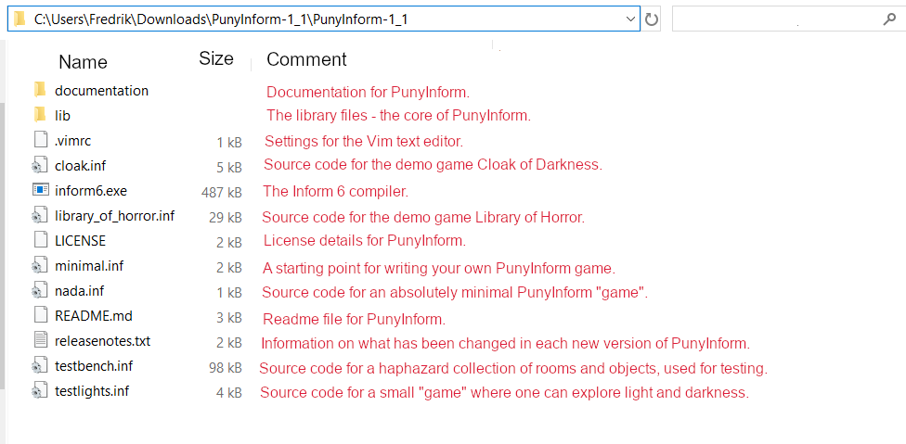

Step 3: Install a Z-code interpreter
While the real selling point for PunyInform is that it allows you to write games that are fast enough and small enough to be played on 8-bits, the games produced will be equally playable on pretty much any computer, and you will soon find that you can do most of the testing on your modern PC. To do this you will need a Z-code interpreter.
PunyInform compiles Inform 6 source code to Z-code, a game format invented by the text adventure wizards at Infocom. A Z-code file is in fact a memory image for a virtual/imaginary computer called the Z-machine. While the Z-machine doesn’t exist, it can be emulated on a wide array of platforms, including the 8-bit computers of the eighties, but also 16-bit computers like Commodore Amiga and Atari ST, as well as computers running MS-DOS, any flavour of Windows, Mac OS, Unix, Linux, Android – you name it. It just takes a Z-code interpreter (an emulator for the Z-machine) for that platform. There is a very popular interpreter called Frotz, which has been ported to many different platforms. For Windows, I recommend you get Windows Frotz.
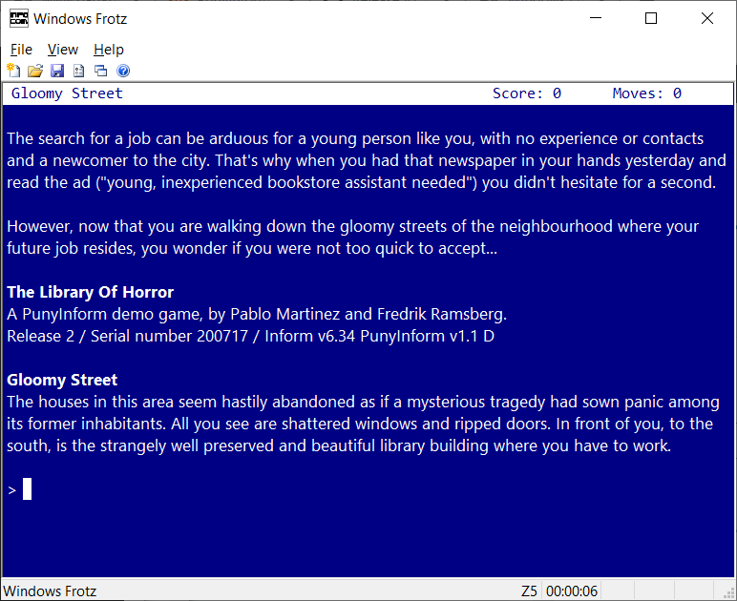
Go to http://www.davidkinder.co.uk/frotz.html , download Windows Frotz and run the installer. Then start Windows Frotz once, to make sure it has set file type associations properly.

Step 4: Start writing your first game
In Windows Explorer, make a copy of the file minimal.inf and call it mygame.inf .
Then open mygame.inf in Notepad (or some text editor you prefer – if you want something really nice, you can get the Atom text editor and install the package “language-inform6” under File -> Settings).
The file mygame.inf should now look something like this:
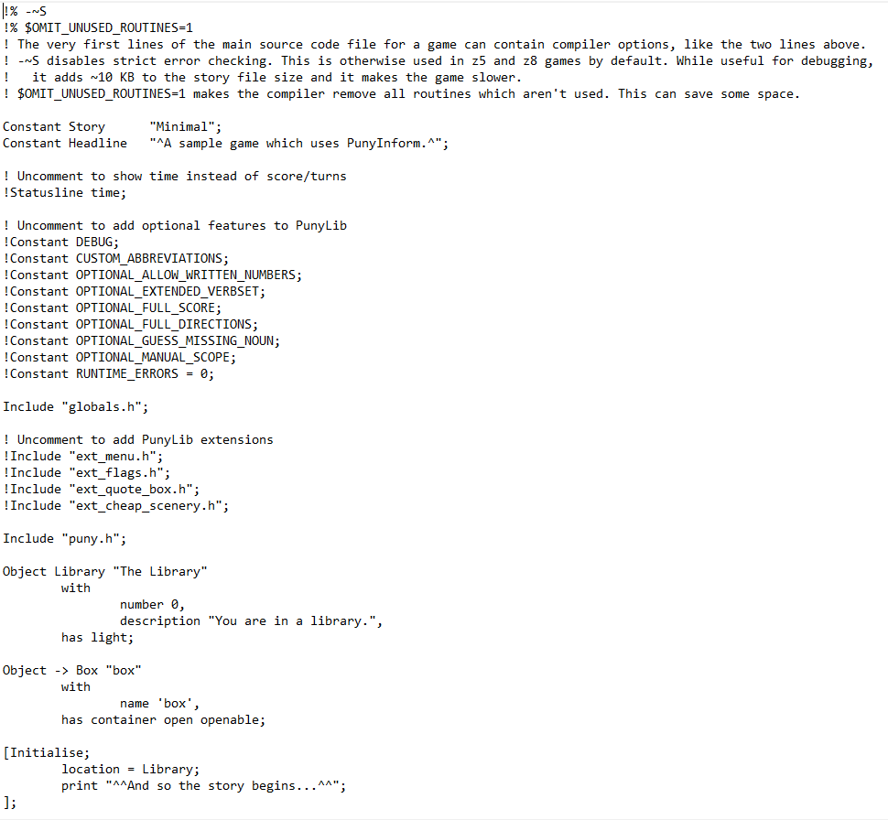
Now change the text in the line which starts with Constant Headline (Line 9 from the top). Change A sample game to This is my first game or something else you find amusing. Save the file.

Step 5: Compile the game
Start a command prompt (In Windows 10, click the Windows Start icon on the Windows menu bar and type cmd , then click on Command Prompt.)
Now use the command CD to go to the base folder of PunyInform. If it’s on a different device, you can type the device letter and “:” to switch to that device first, like D: and then CD to go to the right folder. CD .. goes up one level and CD \ (that’s a backslash character) goes to the root folder on the current device. If you start writing a folder name, you can press the TAB key multiple times to see all files and folders with a matching name. Use DIR to list the files in the current folder.
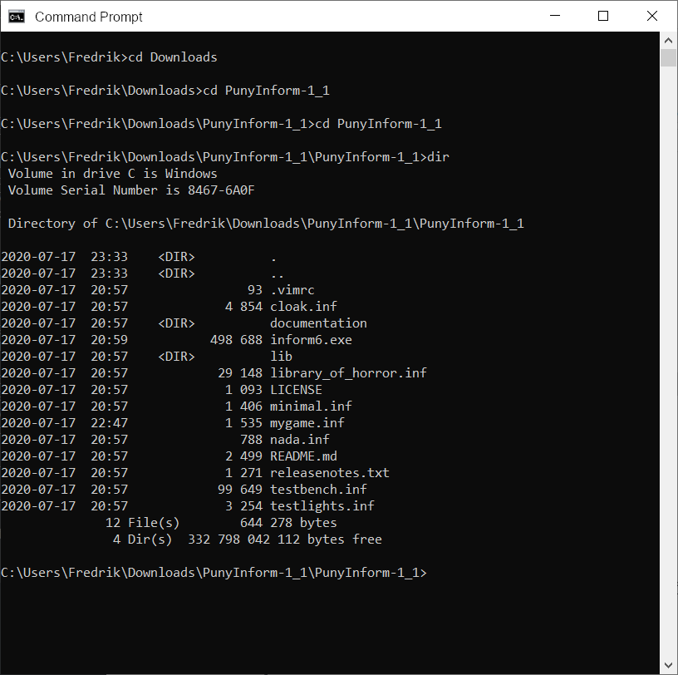
Now, to compile your source code, type:
inform6 -v3 +lib mygame
This tells the Inform 6 compiler to read the source code in mygame.inf and compile it into a Z-code version 3 file (a so-called “story file”) called mygame.z3, and to look for library files in the folder lib. There are many more commandline switches available for the Inform 6 compiler. To list them all, type inform6 -h2 . Most of the time, when using PunyInform, I find myself using the commandline switches -e (to use string abbreviations, making the story file smaller) and -s (to print some statistics on the story file produced).

Step 6: Start your game in Windows Frotz
Now use Windows Explorer to go to the PunyInform base folder. You should see mygame.z3 there. Double-click it. The game should now launch in Windows Frotz.
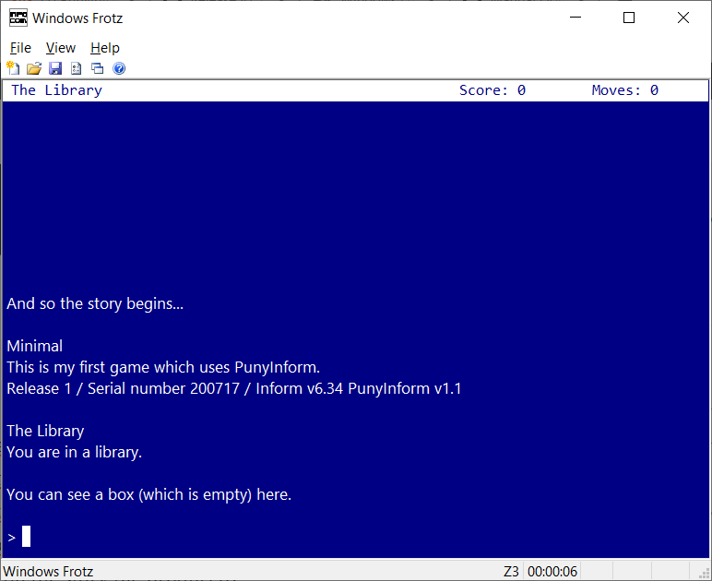

Step 7: Turn your game into a C64 disk image
Now let’s make a Commodore 64 version of your game. To do this, we will bundle the story file with a Z-code interpreter called Ozmoo. Go to http://microheaven.com/ozmooonline/ . Under “Upload Z-code file”, pick the file mygame.z3 and click “Upload”.
Then, under Build game, make sure the story file mygame.z3 is selected, then scroll to the bottom of the page and click “Build”. If all goes well, you get a message that the game was successfully built, and under Files you can see mygame.d64. Click on the filename to download the file.

Step 8: Test your game on an (emulated) C64
If you don’t have a Commodore 64 emulator installed already, this should get you going.
Download WinVICE from https://vice-emu.sourceforge.io/index.html#download and unzip it in a folder of your choice. You may need to install 7-Zip to unzip WinVICE. Then go to this folder in Windows Explorer and double-click x64sc.exe . Click File -> Attach disk image -> Drive #8 and point to mygame.d64. Then type load”*”,8 and press enter. If you get tired of the (realistic) loading time, you can press Alt-W to toggle warp mode (maximum speed). When the game has finished loading, make sure warp mode is turned off, type run and press enter. The game now decompresses and then it starts.
